Topic 1, Alpine SKi House Case Study
Background
Alpine SKi House is a boutique mountain resort that offers year-round spa and outdoor activities such as snow sports, hiking, mountain biking, and more. The resort has been family owned and operated for more than 50 years. The company has been able to remain profitable while not needing to adopt new technologies.
General
Booking at the resort have decreased. The company has decided to focus on creating a tailored, first-class experience for guest. The company also plans to target corporate meetings and events.
The company recently purchased a chatbot named FAQbot from AppSoure. The chatbot uses the resort’s existing FAQS
Communication
* Communication between staff members is primarily conducted through email and SMS text messages.
* Conversations between staff members and guest often lost.
* Conference calls are used for all group meeting
Event Registration
* Corporate customers can reserve a meeting room at the resort to host meetings. The meetings will include lunch and choice of either an inside-spa experience or a seasonally appropriate outdoor activity.
* Event registration is conducted three weeks prior to start of the event. It is assumed that all event attendees will attend the meeting
Check-in process
* Guests wait in lines to check in and obtain name badges. At this time, guests can specify any dietary restrictions and select their activity preference. This can result in long wait times and crowding at the front desk.
* For health and compliance reasons, guests must answer a series of questions with a yes or no answer during check-in. The front desk will ask and record these answers for the resort's records.
Marketing
At the check-in counter, the guests can drop their business cards into a bowl for a chance to win an all-inclusive weekend stay at the resort. The resort uses the business card information to send announcements about promotions and upcoming events.
Resort policies and event inquiries
* A guest can call or send an email to the event coordinator at the resort to get information about hotel policies, snow conditions, or to pre-select their after-meeting event;
* Guests can also go to the website to view the extensive list of frequently asked questions (FAQ) compiled over the years. Many of the answers to the FAQ's are out of date.
General
Alpine Ski House does not employ technical staff and does not have the budget to hire an external firm to develop solutions. There are two team members who are proficient at Microsoft Excel formulas. Any solution created must use the capabilities of current team members.
All solutions must be simple to use, easy to maintain, and represent the brand of the resort.
You must implement the following solutions:
* a centrally managed communication solution
* a customer service solution
* a resort portal
* a chat solution
* a check-in solution
Communication
* Communication between team members must be centrally managed and unified in Microsoft Teams.
* When the company confirms an event they, must provide a list of guest's names and email addresses.
* You must send guests a welcome email that includes a unique registration number for authentication with the resort's portal.
* Guests must receive a separate email to verify proof of ownership for their registration.
Event attendance
* Guests must create an account and sign into a resort portal to confirm their attendance to an event and pre-select an after-meeting event
* Prior to the event, guests must be able to identify any personal dietary restrictions.
Check-in processes
* Check-in processes must be self-service. Each screen must ask for specific data from the guest. The check-in solution will use some data that is stored in Microsoft Excel.
* The check-in solution must continue to function if there are internet issues. If the self-service kiosks are not available, staff must be able to use the check-in solution from within their communication solution.
* The check-in solution must have a screen where the guest will select either yes or no to health and wellness questions.
* Guests must physically interact with each answer before proceeding to the next screen. Guests must be able to confirm any dietary restrictions they may have entered from the portal or add new ones at this time.
* Data must be entered in each screen before users move on to the next screen.
Marketing
* To eliminate the handling of business cards, the check-in solution must be able to translate the contents of the business cards into Alpine Ski House's marketing system.
* The solution must not require any effort or manual entry from the guest to prevent any mistyped information and to make it more appealing to the guest to participate.
Hotel policies and event inquiries
The portal must allow the guest to ask questions about hotel policies, event information, weather reports, and current weather condition at the resort.
Chat solution
The chat solution must specifically address the following key words.
No additional key words will be added until a later implementation phase:
* Snow reports
* Weather conditions
* Start time
* End time
* Event date
* Outdoor activities
* Indoor activities
* Most popular
The chat solution must be available always and not require staff to answer all of the questions. If a question does require a staff member's attention, the solution must determine which staff member is best to assist the customer with the question.
The information in the FAQ on the legacy website must be used in the chat solution but retyping all the data from the website should not be required. If quests ask about topics that are not listed in the FAQ, the chat solution must identify the issue and escalate to a staff member.
Team members must be able to ask their own questions through a centrally managed communication solution instead of using the guest portal. Team members must be able to access the same FAQ across multiple solutions.
Issue
Guest1 inquires about snow conditions several times each day of their stay.
You need to create the FAQ solution content
What should you do first?
- Al Builder
- Suggest topics
- Automate
- Trigger phrases
2. HOTSPOT
You need to design the resort portal's email registration process.
Which solutions should you use? To answer, select the appropriate options in the answer area. NOTE: Each correct selection is worth one point.
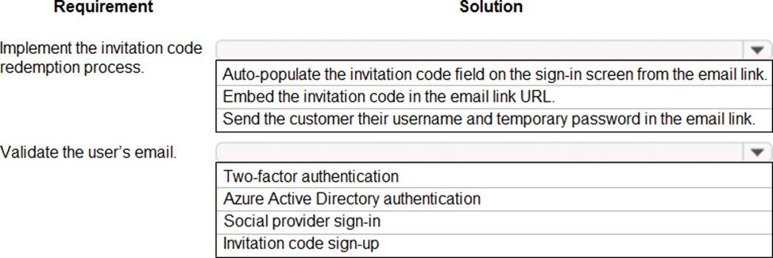
3. You need to design the resort portal to meet the business requirements.
Which data source should you use?
- Microsoft Excel
- Azure SQL Database
- SQL Server
- Common Data Service
4. HOTSPOT
You need to design and create the solution for gathering contact information from guests for marketing purposes.
What should you use? To answer, select the appropriate options In the answer area. NOTE: Each correct selection is worth one point.
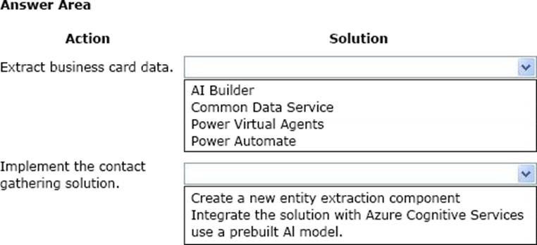
5. HOTSPOT
You need to embed the check-in solution into the communication solution. To answer, select the appropriate options in the answer area. NOTE: Each correct selection is worth one point.
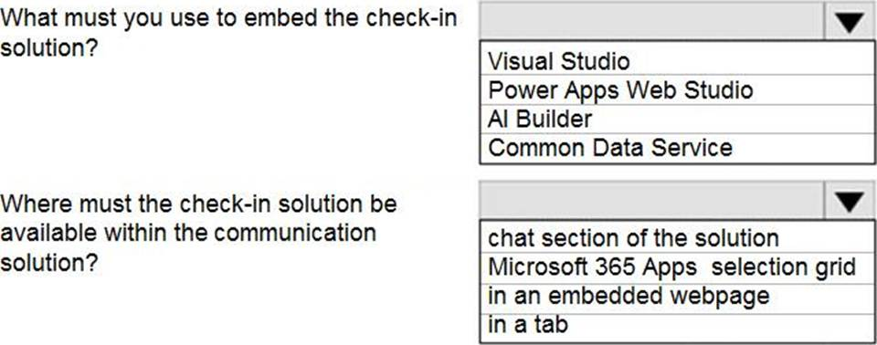
6. HOTSPOT
You need to design the guest check-in solution.
Which technologies should you use? To answer, select the appropriate options in the answer area. NOTE: Each correct selection is worth one point.
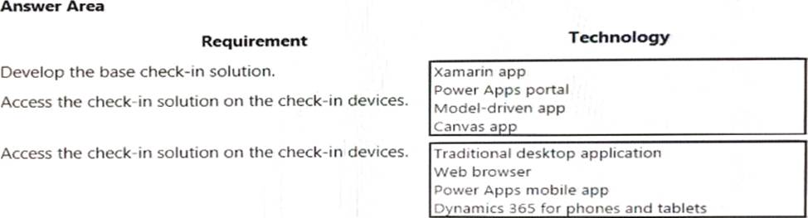
7. You need to add controls to the check-in solution for the health and wellness questions.
Which form control should you use?
- Drop down
- Check box
- Text input
8. You need to design the resort portal’s email registration process.
Which solution should you use?
- Default the invitation code from the email upon logging into the portal
- Auto-populate the invitation code field on the sign in screen from the email link
- Embed the invitation code in the email link URL
- Send the customer their username and temporary password in the email link
9. HOTSPOT
A guest asks about the start time of a specific scheduled event and wants to know what the snow conditions will be like during their stay.
You need to determine how to design the chat solution to answer those questions.
What should you do? To answer, select the appropriate options in the answer area. NOTE: Each correct selection is worth one point.
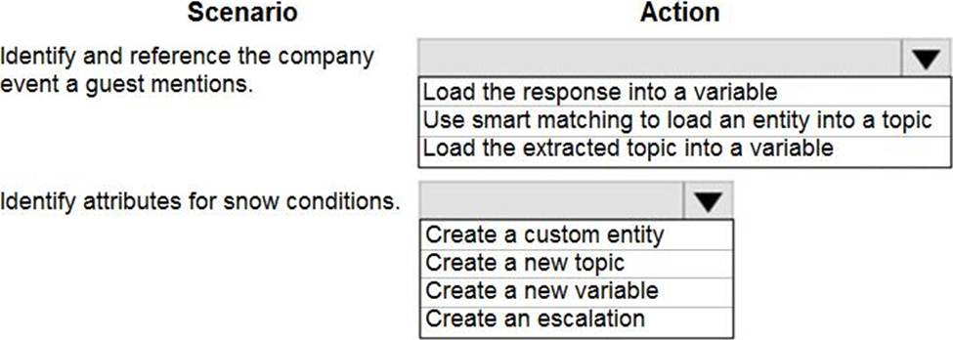
10. You need to design the chat solution to answer the inquiry from Guest1.
Which three components can you use? Each correct answer presents a complete solution. NOTE: Each correct selection is worth one point.
- Variables
- Escalations
- Smart match
- Synonyms
- Topics
11. You need to embed the business card solution in the check-in app.
What you use?
- control
- Button control
- Custom component
- Al Builder component
12. HOTSPOT
You need to design the resort portal’s email registration process.
Which solutions should you use? To answer, select the appropriate options in the answer area. NOTE: Each correct selection is worth one point.
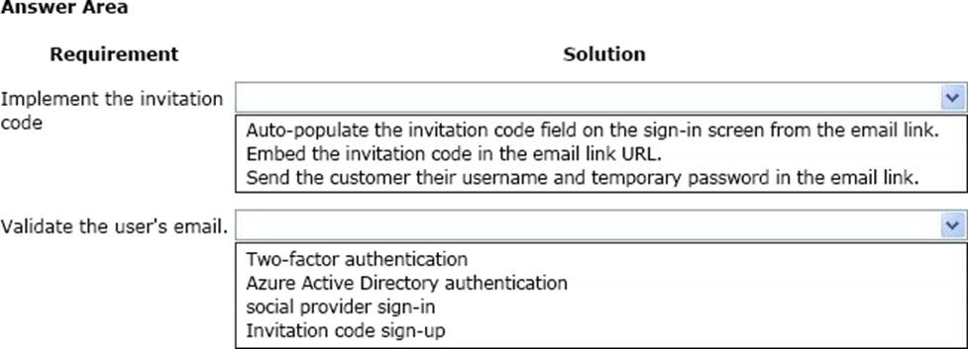
13. Topic 2, ADatum Corp.
Overview
Case studies are not timed separately. You can use as much exam time as you would like to complete each case. However, there may be additional case studies and sections on this exam. You must manage your time to ensure that you are able to complete all questions included on this exam in the time provided.
To answer the questions included in a case study, you will need to reference information that is provided in the case study. Case studies might contain exhibits and other resources that provide more information about the scenario that is described in the case study. Each question is independent of the other questions in this case study.
At the end of this case study, a review screen will appear. This screen allows you to review your answers and to make changes before you move to the next section of the exam. After you begin a new section, you cannot return to this section.
To start the case study
To display the first question in this case study, click the Next button. Use the buttons in the left pane to explore the content of the case study before you answer the questions. Clicking these buttons displays information such as business requirements, existing environment, and problem statements. If the case study has an All Information tab, note that the information displayed is identical to the information displayed on the subsequent tabs. When you are ready to answer a question, click the Question button to return to the question.
Background
ADatum Corporation provides verification and investigation services that are used by insurance companies, law firms, and other organizations in the public sector. Services include verifying an individual’s background, qualifications, and specific scenarios that require onsite visit.
The thorough work ADatum Corporation performs results in highly accurate cases with minimal critical information missing. Because of these high-quality results, ADatum Corporation is quickly proving itself as one of the best in the industry. In recent months, business has significantly increased, with most new business coming from high-profile companies and individuals.
Management has decided to create a new qualification verification (QV) role to help ensure that clients get the most accurate results. This role examines completed work to ensure that nothing is missed.
Current environment
Data storage and retention
✑ All information sent by clients for services is stored in Microsoft Dataverse with a model-driven app as the interface.
✑ Clients enter their data in a website, which then uses a service account to create the records in the Dataverse database.
✑ Team members currently have full access to all Service Request records.
Service requests
✑ The Service Request table includes header information about the individual or organization that is the subject of verification.
✑ New Service Request records are assigned to a queue. All potential users who will be performing the verifications have access to these records.
✑ A service request is assigned to a single user who will ensure that all qualifications are verified. This single user is the only one able to process Qualification records related to their own service requests.
✑ Many required tasks when performing verification services are currently done by using manual processes.
✑ To keep up with demand, ADatum Corporation identifies several processes that can be replaced by using Power Automate flows to hire fewer new staff and keep costs down.
Qualification verification
✑ The qualification table contains details about an individual school degree, professional qualifications, and other qualifications that must be verified.
✑ A service request can have one or more Qualification records associated with it.
✑ Record status is pending verification until the initial team member finishes, at
which point the member changes the status to Complete.
✑ When all qualification records related to a service request are verified either by manual or automated processes, the results are made available to ADatum Corporation’s client.
✑ In the rare event that results are questioned, a new service request is created and verified independently of the previous work that took place.
✑ To complete a service request, users perform the following actions:
Microsoft Power platform environment
✑ The following environments exist: development, testing, user acceptance testing (UAT), and production.
✑ Managed solutions are used to move customizations from the development environment to other higher-level environments. These solutions are created and maintained by the power users and provided to internal IT for deployment when they are ready.
✑ Two managed solutions, Verification Process Automation and Onsite Visit, share several components.
✑ All customizations to Power Platform components are performed by several power users who have received training and are certified as subject matter experts.
✑ Power users have been granted the System Administrator security role in the
development environment.
✑ Corporate policy prohibits power users from writing code due to lack of a formal code review process.
✑ Internal IT will not be able to supply any development resources for this project due to a lack of staff. This means that any customizations and automation created for this project must be low-code/no-code for the power users to implement them.
✑ Customizations created by power users are deployed by internal IT.
Requirements
Process automation
ADatum Corporation plans to establish a new QV department to verify completed work so that the quality of work is maintained. The new process for verifying professional qualifications must automate the following:
✑ Enter data and navigate the authority’s website. The authority website UI changes frequently because the company constantly improves the user experience.
✑ Search page contents for a specified value to determine validity.
✑ Update the corresponding Qualification record in Dataverse.
The new process for completing a service request must automate the following:
✑ Set the Service Request record status to Complete when work on all Qualification records is finished.
✑ Send an email to the client with the results when the service request is completed.
The email must list each qualification as either Valid or Not Valid, depending on the verification.
Qualification verification
Service request results will not be released to clients until all related Qualification records are set to a Complete status.
✑ To check work done by a wide array of users, 10 percent of Qualification records must be double checked.
✑ Qualification records must be automatically assigned to a queue.
✑ Qualification records must be flagged with a new status field named Assigned to ensure that records are rechecked.
✑ Ensure that only QV team members can change the status from Assigned to In Progress to Complete.
✑ Record the name of the QV team member who performed the work and the date completed.
Governance and security
✑ All components required for the verification process must be included in a new solution.
✑ Corporate security requires that deployments to non-development environments must be automated using service accounts.
✑ User security and data access must also be consistent across environments, except for the elevated access of the power users in the development environment.
✑ The Onsite Visit managed solution has a table that is not in the Verification Process Automation managed solution. This table must be upgraded prior to the go-live date without the other shared components.
✑ A VP of sales requires a test environment to demonstrate to potential clients the security policies that are included in their initial offering.
Issues
✑ More employees than are required can access individual client information and continue to have access after a service request is completed.
✑ When users go on vacation, all their outstanding Service Request records are assigned to a substitute employee. The substitute employees are unable to see all the qualifications related to their service requests.
✑ Currently, testing the new QV functionality outside the development environment is not possible due to corporate security policies requiring the same security role across all environments.
✑ Internal IT reports that the solution import to the test environment failed because of missing dependencies related to the flow for completing service requests.
HOTSPOT
You need to address the executive’s concerns regarding unnecessary data access.
Which security changes should you make? To answer, select the appropriate options in the answer area. NOTE: Each correct selection is worth one point.
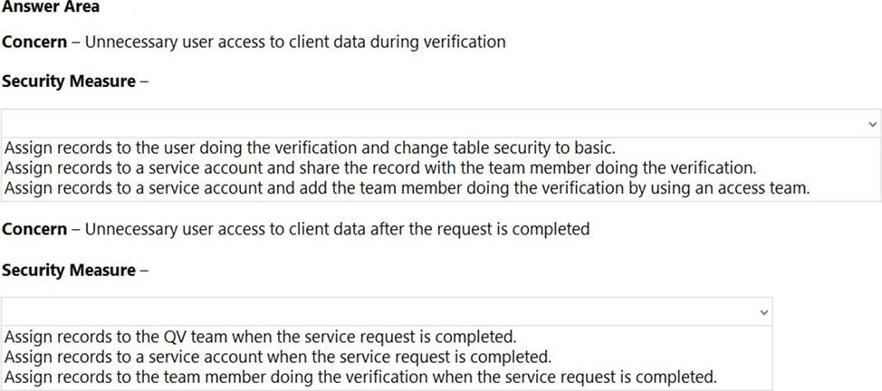
14. HOTSPOT
You need to resolve the issue reported by substitute employees after they are assigned service requests.
How should you configure the system? To answer, select the appropriate options in the answer area. NOTE: Each correct selection is worth one point.
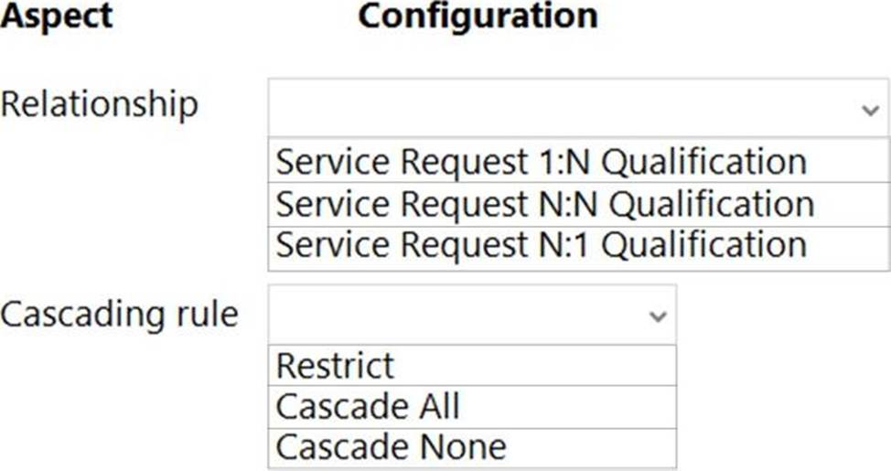
15. You need to implement the requirement for the VP of sales.
What should you do?
- Use a test account with a base security role with QV security added.
- Add the System Administrator security role to your user account.
- Use a test account with only QV security added.
- Add QV security to your user account.
16. You need to be able to move a Power Automate desktop flow used in the verification process to the testing environment.
What should you do?
- Share a copy of the desktop flow with a member of internal I
- Use the Export option in the flow to get the flow identifier and provide it to internal I
- Send a copy of the desktop flow to a member of internal I
- Create the desktop flow in a solution and provide it to internal I
17. HOTSPOT
You create a desktop flow to interact with a certification authority’s website.
You need to get data in and out of the desktop flow.
How should you set up the input and output parameters? To answer, select the appropriate options in the answer area. NOTE: Each correct selection is worth one point.
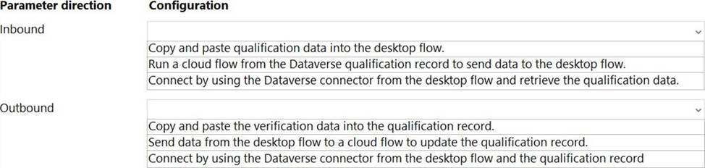
18. HOTSPOT
You need to configure a Power Automate flow to send the email with the results to the client.
What should you use? To answer, select the appropriate options in the answer area. NOTE: Each correct selection is worth one point.
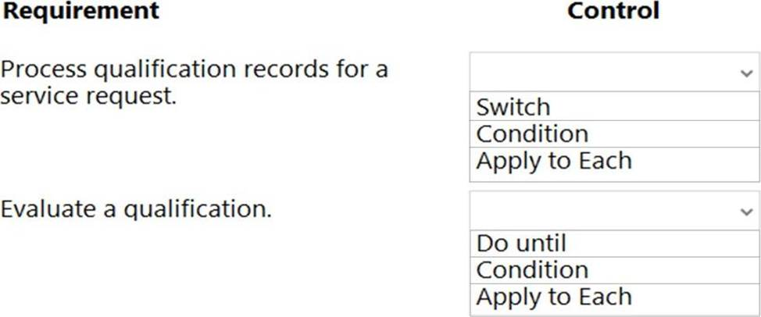
19. You need to capture the Date Completed value from the website using a desktop flow.
Which method should you use?
- Use optical character recognition (OCR) on the screen to locate and extract the value.
- Display an input dialog and prompt the user to enter the value.
- Extract the value from the window the browser is using.
- Retrieve the value from the HTML element in the webpage.
20. You need to assign 10 percent of the Qualification records to the QV queue through table configuration by using a Power Automate flow.
What should you do?
- Create an autonumber column on the Qualification table and assign its qualification records if the number cleanly divides by 10.
- Create a calculated column on the Service Request table that sums the number of qualification records, generates a random number between zero and the number from the new field, and assigns each qualification record if the number generated is 10 percent or less of the value of the new field.
- Create a roll-up column on the Service Request table that is the count of qualification records, generates a random number between zero and the number from the new field, and assigns each qualification record if the number generated is 10 percent or less of the value of the new field.
- Create an autonumber column on the Service Request table and assign its qualification records if the number cleanly divides by 10.
21. HOTSPOT
You need to configure a Power Automate flow to send the email with the results to the client.
What should you use? To answer, select the appropriate options in the answer area. NOTE: Each correct selection is worth one point.
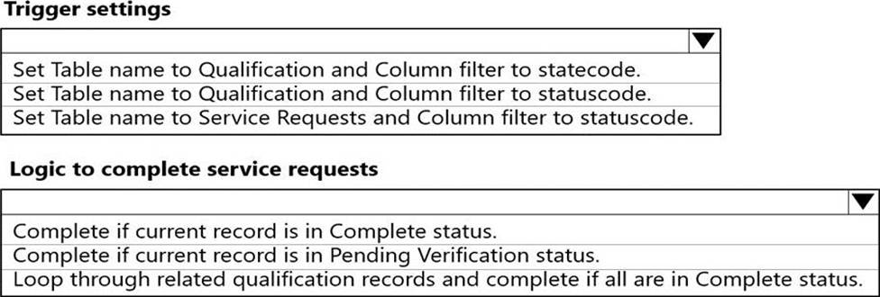
22. You need to set up the new service request completion process.
Which two components should you include in the solution? Each correct answer presents a complete solution. NOTE: Each correct selection is worth one point.
- connection reference
- business process flow
- Power Automate flow
- connection
23. You need to add the missing components to the Verification Process Automation solution.
Which two components should you add? Each correct answer presents a complete solution. NOTE: Each correct selection is worth one point.
- Service Request statuscode field
- Dataverse connection reference
- Qualification statuscode field
- On-premises data gateway reference
- Outlook connection reference
24. HOTSPOT
You need to coordinate updates and deployment for managed solutions containing completed work without disrupting the system.
What should you do? To answer, select the appropriate options in the answer area. NOTE: Each correct selection is worth one point.
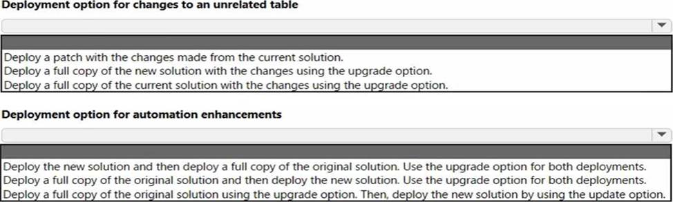
25. You need to create the automation for the qualification verification process.
Which two actions should you perform? Each correct answer presents a complete solution. NOTE: Each correct selection is worth one point.
- Add a Dataverse connector.
- Add an Outlook connector.
- Create an on-premises data gateway reference.
- Update the Qualification records to finished.
- Create a Service Request record.
26. HOTSPOT
You need to address the unnecessary data access.
Which security changes should you make? To answer, select the appropriate options in the answer area. NOTE: Each correct selection is worth one point.
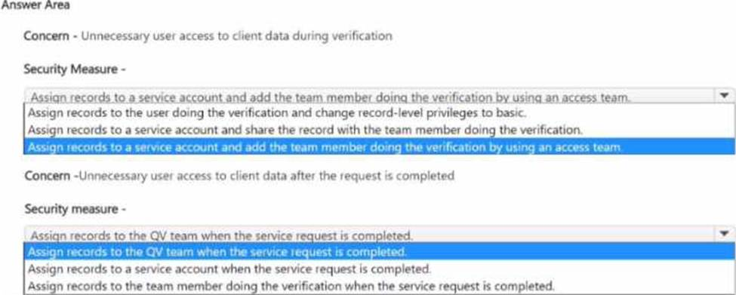
27. Topic 3, Bellows College Case Study
Overview
Bellows College is a post-secondary school that wants to start a football team. The college uses Microsoft Power Platform to manage its recruiting efforts. The registration team and assistants use model-driven apps. The coaches use canvas apps on their mobile devices.
Prospects are considered underage if they are younger than 18 years old at the time of registration.
Environment
• Custom code is not allowed in the system.
• Server-side synchronization is configured for emails, appointments, contacts, and tasks.
• The database and file storage of Dataverse must be minimized to keep costs low. Contact table
• Birthdate is a custom date and time field.
• Age at Registration is a calculated Held that displays the age of the prospect at the time of registration.
• Current Age is a calculated field that displays the age of the prospect based on the current date and time.
Evaluation Table
• The Evaluation table is a custom table used to track evaluation criteria.
• Evaluation records cannot be manually created.
• Users must not be able to continue until an evaluation record is created automatically for the prospect.
Consent table
• The consent forms completed by the parents are stored as records in the Consent table.
• Occasionally, a parent cannot complete the consent online and a paper copy must be printed. The signed copy must be scanned and stored with the consent record.
team website
• The consent forms completed by the parents are stored as records in the Consent table.
• Occasionally, a parent cannot complete the consent online and a paper copy must be printed. The signed copy must be scanned and stored with the consent record.
Requirements
• The team website is created by using Power Pages.
• A starter layout template was used to create the site.
• The site consists of five pages:
o Home: A page open to everyone to view the announcements from the team,
o Schedule: A page open to everyone to view the tryout and game schedule,
o Evaluations: A page that displays tracking from the evaluation table.
Prospects are able to view their own information only.
o Forms: A page that displays the consent form,
o Contact Us: A page for anyone to submit questions and comments.
• Two web roles for authenticated users are created: Primary Contact User and Prospect User.
o All primary contacts and prospects are assigned to their respective roles.
Registration
• Parents and prospects are created as contacts and must be linked.
• The registration team must be able to rapidly create prospects without navigating away from the Parents form. Only the First Name, Last Name, and Birthdate fields should be displayed for the team.
• Assistants must be able to update prospect information and add teams that the prospect has previously played on to a subgrid.
Parent consent
• When a prospect is underage, a Primary Contact field will appear. The field must be populated before the prospect record can be saved.
• A view named Underage Prospects that lists all underaged prospects is required.
• The Underage Prospects view must run once a week without requiring modifications to display correct information.
• A consent email must meet the following requirements:
o be sent to the primary contact of each new underage prospect
o contain a link to the team website
o be automatically sent weekly and tracked to the contact record in Dataverse
o include the current date using the full month name, date, and year Evaluations
• Coaches rate prospects each day on a scale of 1-10 in three categories: endurance, coordination, and skill.
• The total of the three categories is displayed at the bottom of the form. If the total for the day is greater than 25, the number should appear green.
DRAG DROP
You need to configure the Total field on the Evaluation form.
Which property should you select for the formula? To answer, move the appropriate property to the correct formula. You may use each property once, more than once, or not at all. You may need to move the split bar between panes or scroll to view content
NOTE: Each correct selection is worth one point.
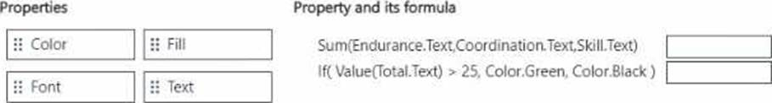
28. You need to view website questions and comments. Where should you view this information?
- Lead
- Feedback
- Contact
- Evaluations
29. DRAG DROP
You need to create forms required for the registration team and assistants.
Which form types should you create? To answer, move the appropriate form types to the correct roles. You may use each form type once, more than once, or not at all. You may need to move the split bar between panes or scroll to view content. NOTE: Each correct selection is worth one point.
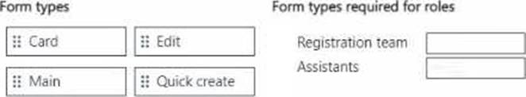
30. DRAG DROP
You need to set up webpage permissions.
Which permissions must you set? To answer, move the appropriate permissions to the correct page. You may use each permission once, more than once, or not at all. You may need to move the split bar between panes or scroll to view content. NOTE: Each correct selection is worth one point.
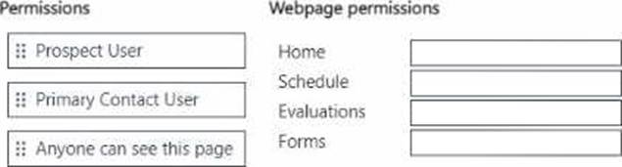
31. HOTSPOT
You need to create a flow to send an email to the primary contacts.
Which actions should you configure? To answer, select the appropriate options in the answer area. NOTE: Each correct selection is worth one point.
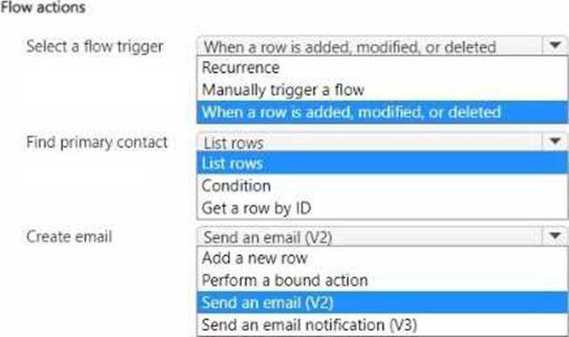
32. You need to format the Current Date field for parental consent.
What should you use?
- dynamic content
- expression
- switch
- condition
33. You need to store scanned consent forms. Where should you store the forms?
- SharePoint
- Attachment
- Column
- Notes
34. You need to create the evaluation record for a prospect.
What should you use?
- a plug-in
- a cloud flow
- a quick create form
- a classic Dataverse workflow
35. HOTSPOT
You need to configure the Primary Contact field.
What should you configure? To answer, select the appropriate options in the answer area. NOTE: Each correct selection is worth one point.
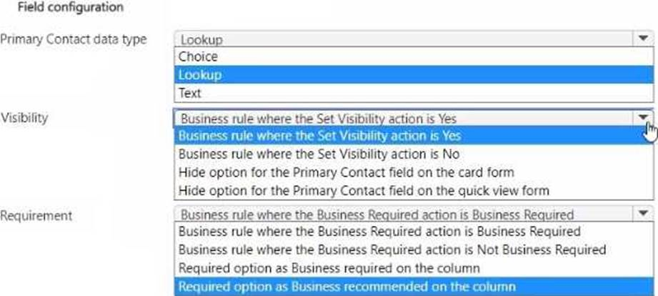
36. HOTSPOT
You need to create a filter for the Underage Prospects view.
How should you set up the expression for the filter? To answer, select the appropriate options in the answer area. NOTE: Each correct selection is worth one point.
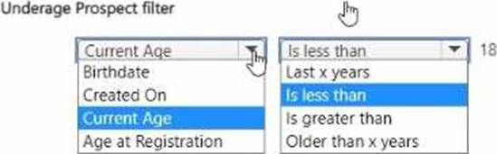
37. Topic 4, Contoso Suites
Background
Contoso Suites is an animal shelter that specializes in finding homes for dogs that have been given up
by their owners. The shelter can house up to 20 dogs.
The shelter is implementing one model-driven Power Apps app to track the dogs and schedule meetings with potential adopters. No other apps will be created.
The model-driven app uses Dataverse with out-of-the-box functionality when possible.
Dataverse is set up with the following configuration:
• The solution prefix 'cs' is used for all new components.
• Only the root business unit is used.
• All tables are stored in Dataverse and do not require rapid scaling.
• Exchange server-side sync is not configured.
Adopters
• Adopter information is stored in a Contact table.
• Contacts are considered to be duplicates if they have the same email address and last name.
• Adopters are often late to meetings, so a reminder email is sent to them two hours before their meeting.
• The email reminders must not be tracked in the system.
Dogs
• Dog information is stored in a Dog table, which is organization owned.
• Breed, size, and weight are fields in the table.
Dog residency
• A Resident table tracks the stay of each dog.
• Each resident record has a lookup for the dog and its food.
• The food type and amount are logged on each resident record. Auto-posting is not configured for changes to food type and amount.
• A fee of $120 is in a currency column named Adoption Fee. This fee can be changed depending on the adoption circumstances.
• A formula column named Deposit is automatically populated with 20% of the adoption fee.
• A resident record is generated automatically when a dog record is created. This is the only way a
resident record can be created.
Exercise and feedings
• Exercise for the dogs is tracked in an Exercise table.
• Feedings are tracked in a Feeding table.
• Exercise and feeding records appear in a resident record timeline.
Care staff
• The care staff must be able to view who changed the food type and the amount that was given, for up to three months ago.
• The staff must be able to update the weight of a dog on the resident record.
• The staff report that the buttons are too small on the touch screen they use to log exercise and feeding.
• The staff must be able to view who the adopters are for upcoming meetings. The staff must not be able to update adopter information.
Administrate staff
• Administrative staff must receive a weekly list of duplicate contacts. Duplicate alerts must not appear when a staff member saves a new contact.
• When an adopter wants to adopt a dog. the staff must perform a series of adoption duties in order.
The following duty list must be displayed on the screen:
o Commitment:
■ Obtain adopter signature in a commitment document.
■ Collect deposit
o Pre-pickup:
■ Document spay or neutering date.
■ Perform spay or neutering.
■ Document pickup date.
o Pickup:
■ Collect full payment.
■ Verify dog is picked up.
o A dog must be picked up no sooner than two days after spaying or neutering.
o A pop-up window must appear with an error message if the Pickup date is too soon.
o Only administrative staff must be able to add new adopters and dogs.
HOTSPOT
You need to ensure that an appropriate date is selected for dog pickup.
What should you configure? To answer, select the appropriate options in the answer area. NOTE: Each correct selection is worth one point.
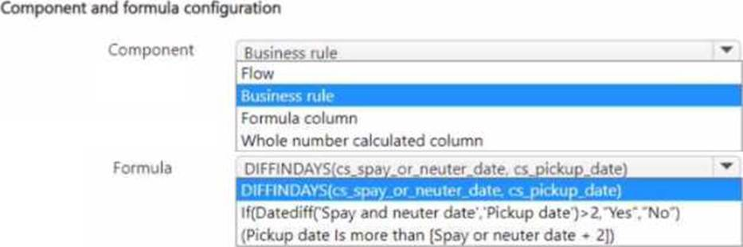
38. DRAG DROP
You need to enable the care staff to update a dog's weight.
Which three actions should you perform in sequence? To answer, move the appropriate actions from the list of actions to the answer area and arrange them in the correct order.
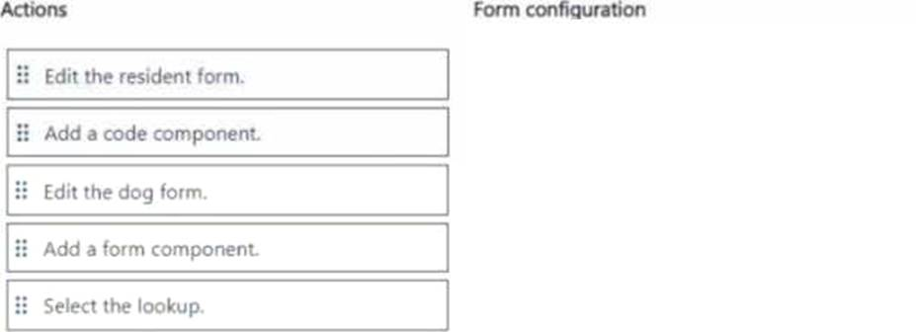
39. You need to improve the user experience for the care staff to log exercise and feeding.
What should you create?
- Model-driven app form
- Custom page in a model-driven app
- Canvas app
- Power Bl report
40. You need to configure the Deposit column.
How should you write the formula?
- 'Adoption Fee" ■ 0.20
- Decimal (‘Adoption Fee" 20%)
- Adoption Fee' "20%
- Decimal (‘Adoption Fee’) ■ 0.20
41. You need to create adoption duties for the administrative staff.
What should you create?
- business rule
- business unit
- business process flow
42. You need to manage contact duplicates for the administrative staff.
What should you do?
- Create two duplicate detection rules and one duplicate detection job.
- Create two duplicate detection rules and two duplicate detection jobs, and update duplicate detection settings.
- Create one duplicate detection rule and one duplicate detection job, and update duplicate detection settings.
43. DRAG DROP
You need to set up a security role for the care staff.
Which privileges should you set? To answer, move the appropriate privileges to the correct create, read, write tables. You may use each create, read, write privileges once, more than once, or not at all. You may need to move the split bar between panes or scroll to view content. NOTE: Each correct selection is worth one point.
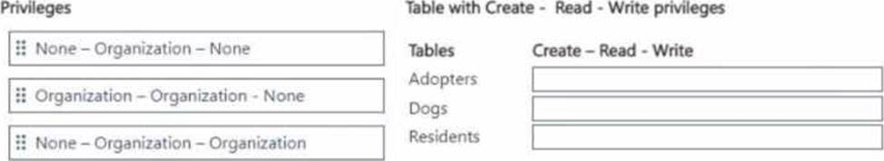
44. HOTSPOT
You need to set up the capability to view the change history for the food type and amount.
What should you set up? To answer, select the appropriate options in the answer area. NOTE: Each correct selection is worth one point.
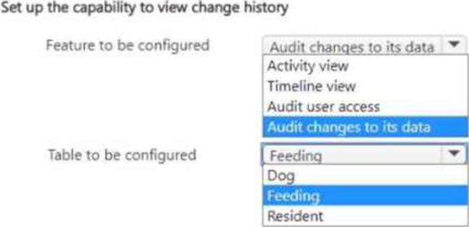
45. HOTSPOT
You need to create reminders for the adopters.
What should you use for each requirement? To answer, select the appropriate options in the answer area. NOTE: Each correct selection is worth one point.
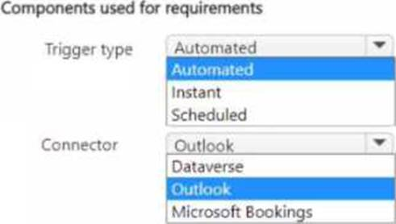
46. DRAG DROP
You need to define the table types for Contoso Suites.
Which table type should you define for each requirement? To answer, move the appropriate table types to the correct tables. You may use each table type once, more than once, or not at all. You may need to move the split bar between panes or scroll to view content. NOTE: Each correct selection is worth one point.
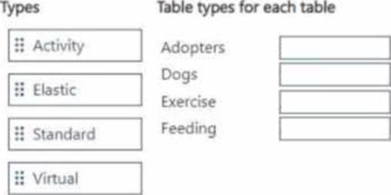
47. Topic 5, Misc. Questions
DRAG DROP
A company uses Common Data Service to store sales data.
For the past few quarters, the company has experienced a decrease in sales revenue. The company wants to improve sales forecasting.
The company plans to use Al Builder to implement the solution. You select fields that will be used for prediction.
Which three actions should you perform in sequence? To answer, move the appropriate actions from the list of actions to the answer area and arrange them in the correct order.
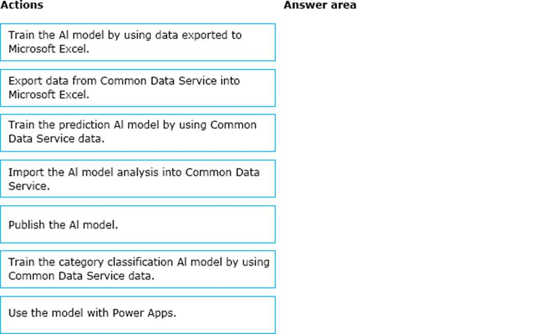
48. HOTSPOT
You configure an alert in Power Bl.
You need to alert users when the value of a tile exceeds a threshold. To answer, select the appropriate options in the answer area. NOTE: Each correct selection is worth one point.
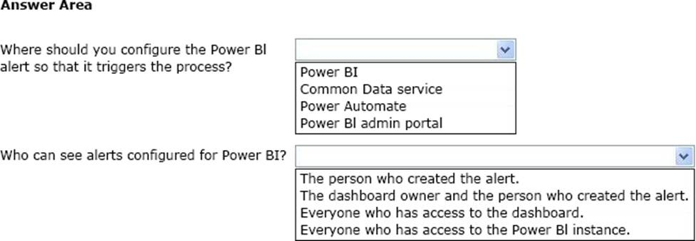
49. HOTSPOT
A company uses Common Data Service to manage account and contact information.
The company plans to use the Al Builder model to make key business decision.
You need to integrate prebuilt Al Builder models with Power Automate.
Which models should you use? To answer, select the appropriate option the answer area. NOTE Each correct selection is worth one point.
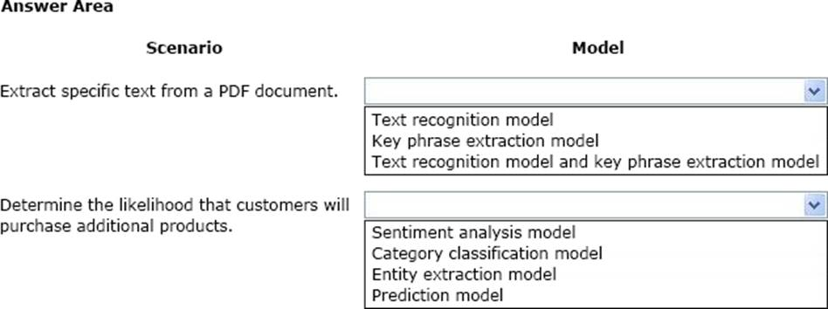
50. You use Power Bl Desktop to configure Power Bl reports and dashboards.
You need to create a canvas app that displays account information and include the app in a Power Bl report.
Which three actions should you perform? Each correct answer presents part of the solution. NOTE Each correct selection is worth one point.
- Publish the report to the Power Bl service.
- Connect to Common Data Service from Power Bl Desktop.
- Connect Common Data Service from Power Bl Desktop. Selected required fields from the Accounts table.
- From the Power Apps Insert menu, add a Power Bl
- From the Power Bl Desktop menu, insert a Power Apps visual and include the required fields in the Power Apps data.
51. DRAG DROP
You create a report by using Power Bl Desktop and publish the report to the Power Bl service. You enable Power Bl visualization embedding in a model-driven app.
You need to configure the model-driven app to display a Power Bi tile
Which three actions should you perform in sequence? To answer, move the appropriate actions from the list of actions to the answer area and arrange them in the correct order.
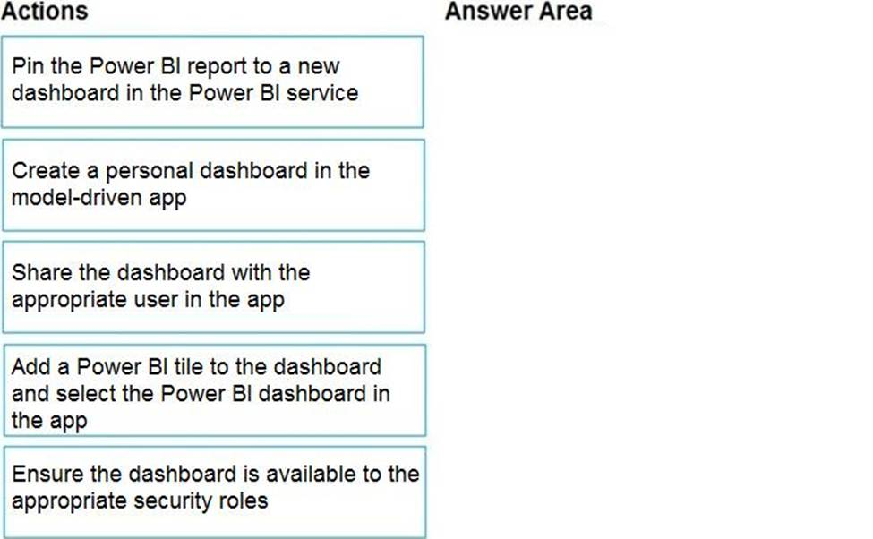
52. You manage the Dynamics 365 Customer Service environment for an organization.
Microsoft SharePoint will not be deployed in the environment for a year.
You need to integrate Microsoft Office 365 solutions with the Dynamics 365 instance to help the sales team with internal collaboration efforts.
Which three solutions can you currently implement? Each correct answer presents part of the solution. NOTE: Each correct selection is worth one point. NOTE: Each correct selection is worth one point.
- Microsoft OneDrive for Business
- Microsoft Yammer
- Microsoft OneNote
- Microsoft Skype for Business
- Microsoft Exchange Online
53. HOTSPOT
You set up a new instance of Dynamics 365 for Customer Service.
Users report a variety of issues working with cases on mobile devices.
You need to configure the mobile app to be able to view cases. NOTE: Each correct selection is worth one point.
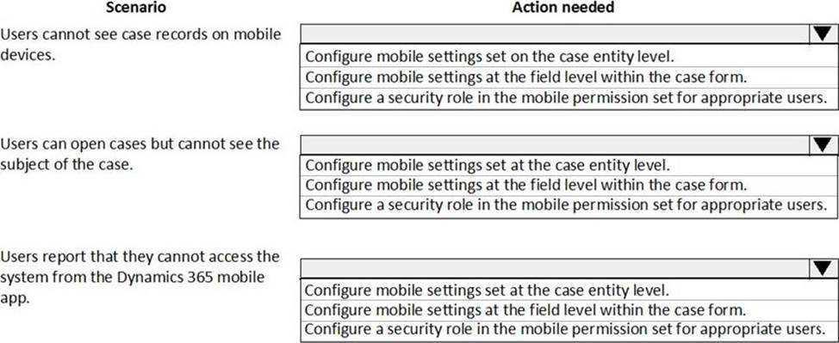
54. You have a canvas app that allows users to view, select and purchase products. The app uses a Gallery control to display products and checkboxes that allow users to select products.
When users select items from the product catalog, they move to a different screen to complete a purchase.
Users must be able to clear all product selections when they click the button.
You need to configure the button.
What should you do?
- Use the Reset (Control) formula and pass the gallery control as a parameter to the Reset formula.
- Use the Reload(control) formula and pass the gallery control as parameter to the Reload formula.
- Use the ForAall( ) function to iterate through each item of the Gallery and clear user selections.
- Set the OnCheck value to populate a collection and the OnUncheck value to remove the item from the collection. Clear the collection when the user selects the button.
55. You create a Power Apps portal to provide training and documentation for students. Students create
a profile on the portal and then select and pay for courses.
You plan to add free courses to the training portfolio. Free courses must be automatically available to all students when they sign in.
You need to assign default permissions to students.
What should you do?
- Create an entity for managing free courses. Create a Students web role and set the Authenticated Users role option to true. Create appropriate entity permissions to access the free course entity records and assign the entity permissions to the web role.
- Create an entity for managing free courses. Create entity permission records to provide access to entity records for free courses and assign the entity permissions to users when they register on the portal for the first time.
- Create a Students web role and set the Authenticated Users Role option to true. Assign the web role to each registered user.
56. You are creating a canvas app.
A user will click a button on each screen of a Power Apps app to proceed to the next screen.
You need to implement an action that selects the next screen that the user sees.
Which event should you handle?
- OnLoad
- OnCheck
- ScreenTransition
- OnSelect
57. DRAG DROP
You are a Dynamics 365 administrator.
You create a new app.
You need to create the site map for the app.
Which three actions should you perform in sequence? To answer, move the appropriate actions from the list of actions to the answer area and arrange them in the correct order.
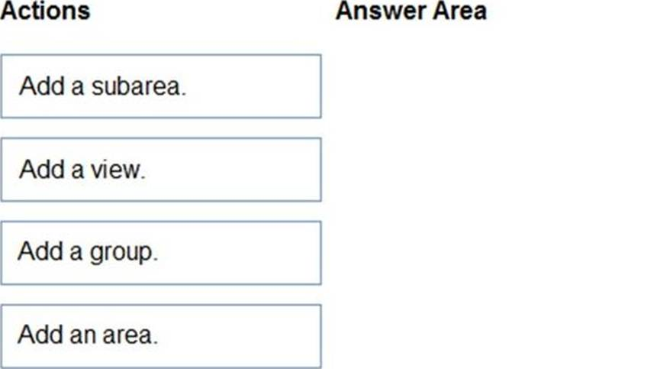
58. HOTSPOT
You ate a Dynamics 365 help desk administrator
You need to create a dashboard that displays information on help desk cases that ate handled each week.
Which dashboard components should you use? To answer, select the appropriate options in the answer area. NOTE: Each correct selection is worth one point.
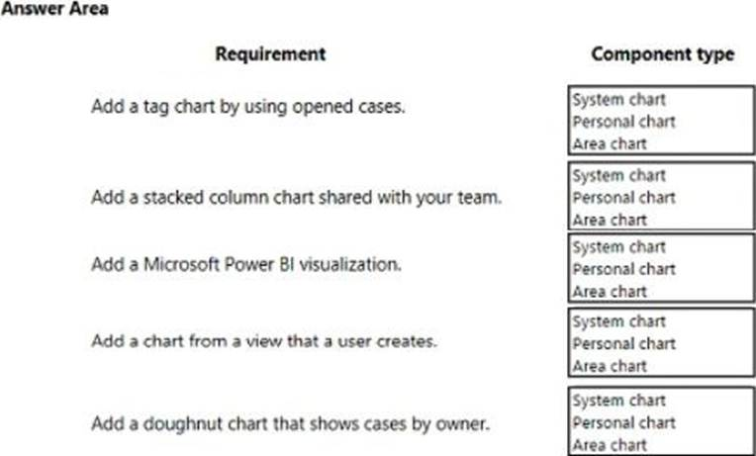
59. HOTSPOT
The business team provides the following list of features that they would like you to implement:
• Group by or sort columns in the current view.
• Configure a business rule to show an error message.
• Edit values in calculated fields.
• Edit the Address composite field.
• Use the editable grid on mobile phones.
Which actions can you perform? To answer, select the appropriate options in the answer area. NOTE: Each correct selection is worth one point.
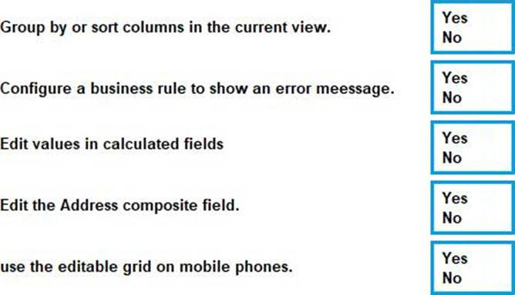
60. You are a Dynamics 365 Customer Service system administrator. You create an app for the sales team.
Members of the sales team cannot access the app.
You need to ensure that sales team members can access the app.
Where should you configure app permissions?
- Security Roles
- Manage Roles
- Dynamics administration center
- Dynamics 365 home
61. HOTSPOT
You are designing a canvas app that connects to Common Data Service.
You need to configure the app to meet the requirements and ensure that the canvas app is available offline.
What should you implement? To answer, select the appropriate options in the answer area. NOTE: Each correct selection is worth one point.
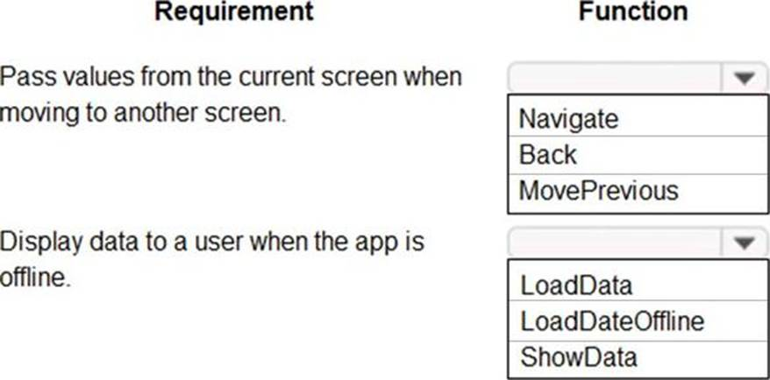
62. You plan to create user interface (Ul) flows to automate several web-based business processes that you currently perform manually. You need to ensure that users can create and run web Ul flows.
Which three components must you install and configure on user's devices? Each correct answer presents part of the solution. NOTE Each correct selection is worth one point.
- Ul Flows application
- Selenium IDE
- Latest version of Microsoft Edge
- On-premises data gateway
- Latest version of Mozilla Firefox
63. You configure and test a user interface (Ul) flow. You plan to run the flow as a scheduled flow.
The Ul flow must run on a Windows 10 device. As part of process automation, the Ul flow must sign into the Windows 10 device with the credentials for a user account named User1.
You need to ensure that the flow runs during non-peak hours and requires no physical user intervention.
What should you do?
- Ensure that all user sessions are signed out except for locked user sessions.
- Ensure that the User1 account has an active user session on the device.
- Ensure that all user sessions are signed out.
- Ensure that there are no active user sessions on the device.
64. You are creating a new business process flow to qualify leads.
You create an action. The action is not available inside the Action Step.
You need to make the action available to the Action Step.
Which two steps must you perform? Each correct answer presents part of the solution. NOTE: Each correct selection is worth one point.
- Activate the action.
- Select Run as an on-demand process
- Add at least one step to the action.
- Ensure that the entity for the action matches the corresponding entity for the business process flow stage.
65. DRAG DROP
You are designing a desktop user interface (Ul) flow.
The Ul flow automates legacy software.
You need to prepare data for transfer to a Microsoft SharePoint list.
Which four actions should you perform in sequence? To answer, move the appropriate actions from the list of actions to the answer area and arrange them in the correct order.
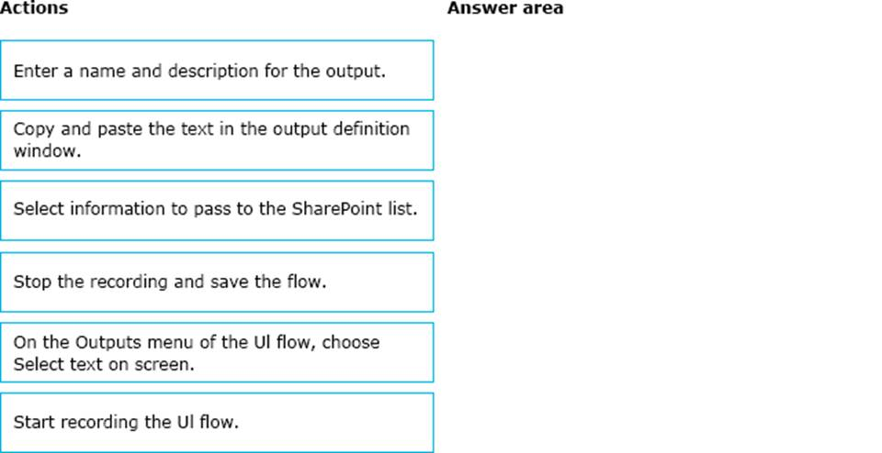
66. A company uses Common Data Service to manage prospects. The company has a business process flow named BPFA that is associated with the Prospect entity to streamline the prospect management process.
You add a field named Category to the Prospect entity. You create additional business process flows. You apply the business process flows to Prospect records based on the selected category. Users can switch to any other newly configured business process flows but must not use BPFA.
You need to configure the solution.
What are two possible ways to achieve this goal? Each correct answer presents a complete solution. NOTE Each correct selection is worth one point.
- Remove all of the privileges for BPF
- Deactivate BPF
- Use a business rule to prevent users from switching to BPF
- Change the display order of the business process flows to move BPFA to the bottom of the list.
67. HOTSPOT
You ate a Dynamics 365 Customer Engagement administrator. You create workflows to automate business processes.
You need to configure a workflow to meet the following requirements:
• Be triggered when a condition is met.
• Run immediately.
• Perform an action when a condition is met.
How should you configure the workflow? To answer, select the appropriate configuration in the answer area. NOTE: Each correct selection is worth one point.
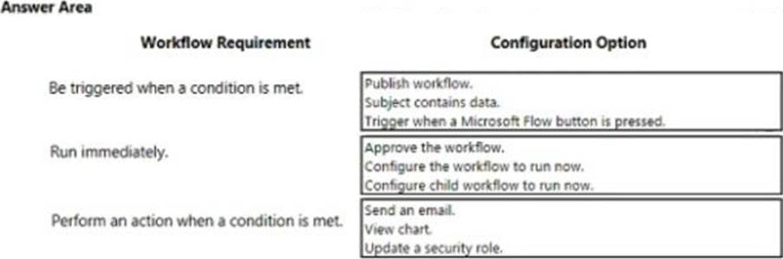
68. You manage Dynamics 365 for a company.
You must prevent users from launching and using Power Automate.
You need to hide the Flows button on the user interface.
Which configuration setting should you change?
- the Customizations section of System Settings
- the Site Map
- the Buttons tab of Flow
- the Entity component of the default solution
69. HOTSPOT
You have a business process flow (BPF) that interacts with the Account entity.
You configure a new version for the BPF and add a new stage at the beginning.
You need to identify the impact of the new version on the existing account records.
What is the outcome in each scenario? To answer, select the appropriate options in the answer area. NOTE: Each correct selection is worth one point.
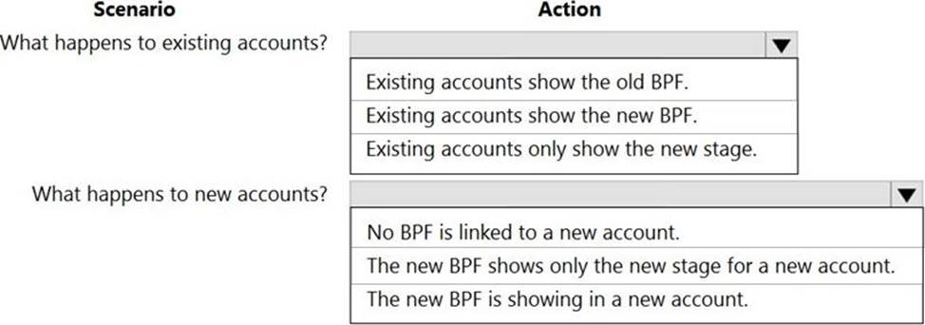
70. DRAG DROP
You plan to automate several different processes by using Power Automate.
Each process has unique characteristics.
You need to recommend components for each process.
Which components should you recommend? To answer, drag the appropriate components to the correct processes. Each component may be used once, more than once, or not at all. You may need to drag the split bar between panes or scroll to view content. NOTE: Each correct selection is worth one point.
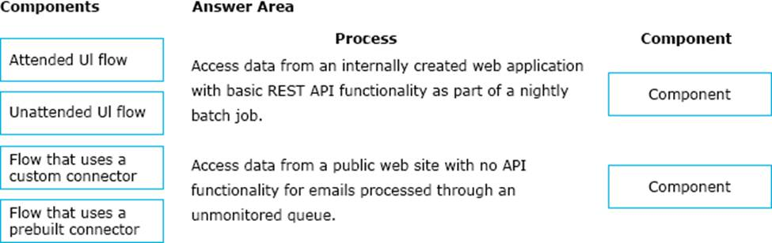
71. You are creating a business rule to implement new business logic.
You must apply the business logic to a canvas app that has a single screen named Screen1.
You need to configure the scope for the business rule.
Which scope should you use?
- All Forms
- Entity
- Screen1
- Global
72. DRAG DROP
You are a Dynamics 365 for Customer Service developer.
You must trigger a mobile notification whenever a specific hashtag is posted from Twitter. The notification will send email to the company’s social media teams distribution list.
You need to create a connection to the Twitter service and build a solution.
Which four actions should you perform in sequence? To answer, move the appropriate actions from the list of actions to the answer area and arrange them in the correct order.
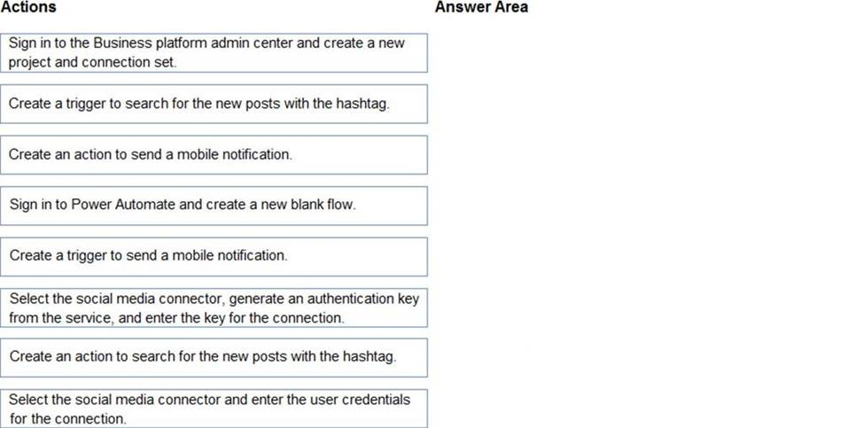
73. HOTSPOT
You are a Dynamics 365 Customer Service administrator.
You need to configure the following automation for the sales team:
* Send an email when the status changes on an Opportunity.
* Text the sales manager when an Opportunity is created.
* Create a Wunderlist task when an Opportunity is open for 30 days.
Which tool should you use for each requirement? To answer, select the appropriate options in the answer area. NOTE Each correct selection is worth one point.
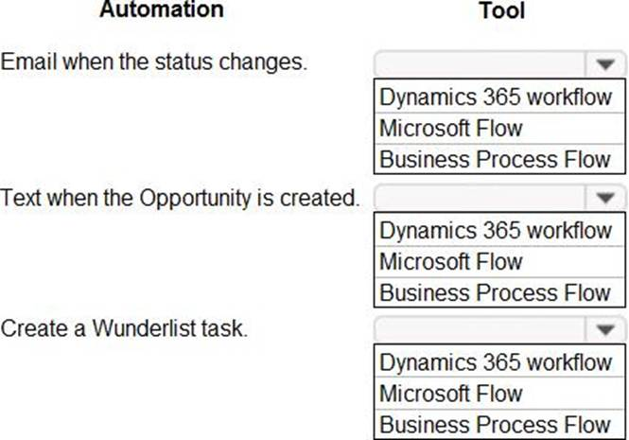
74. You are designing a Power Virtual Agents chatbot.
You observe that the environment you plan to use does not appear as an option in the Power Virtual Agents user interface.
You need to ensure that you can create the chatbot in the environment that you want to use.
What should you do?
- Create an environment in a supported region.
- Convert the environment to a sandbox environment.
- Change the region for the environment.
75. DRAG DROP
You are designing a chatbot for a sports outlet.
You need to complete the chatbot.
Which features should you use? To answer, drag the appropriate features to the correct requirements. Each feature may be used once, more than once, or not at all. You may need to drag the split bar between panes or scroll to view content. NOTE Each correct selection is worth one point.
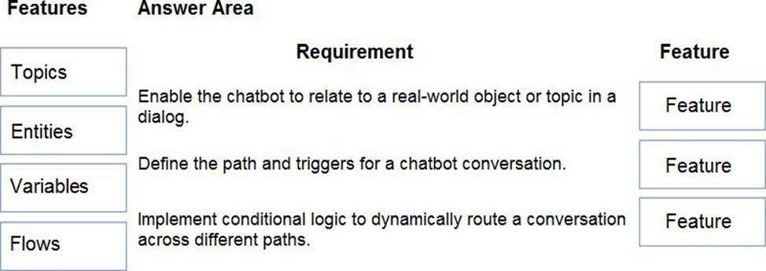
76. HOTSPOT
You create a new Power Virtual Agents chatbot for an organization.
Testing and production deployment of the chatbot are not complete.
You need to ensure that appropriate users can access the chatbot.
Which methods should you use? To answer, select the appropriate options in the answer area. NOTE: Each correct selection is worth one point.
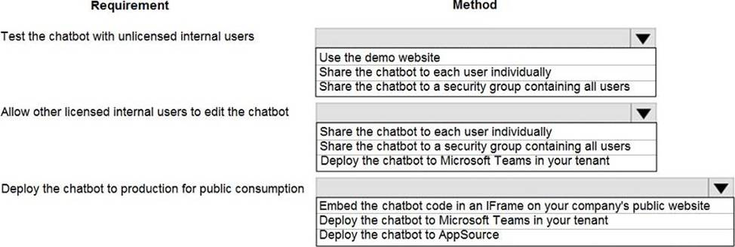
77. You are creating a Power Virtual Agents chatbot that uses multiple topics.
Each user interaction can reference more than one topic.
You need to be able to capture a value in an initial topic and use it in subsequent topics.
Which type of variable should you create?
- Bot
- Topic
- Context
78. A company has a custom website.
You need to embed a Power Virtual Agents chatbot into the website.
What should you use?
- Webpage URL
- Form ID
- Bot ID
- IFrame
79. You are designing a Power Virtual Agents chatbot.
The chatbot must be able to maintain customer information if the conversation topic changes during a dialog.
You need to configure variables to store customer name and email address.
Which type of variable should you create?
- session
- topic
- bot
- slot
80. DRAG DROP
You are a Dynamics 365 for Customer Service administrator.
You must create a form for team members to use.
The form must provide the ability to:
✑ Lock a field on a form.
✑ Trigger business logic based on a field value.
✑ Use existing business information to enhance data entry.
You need to implement business rule components to create the form.
Which components should you use? To answer, drag the appropriate components to the correct requirements. Each component may be used once, more than once, or not at all. You may need to drag the split bar between panes or scroll to view content. NOTE: Each correct selection is worth one point.
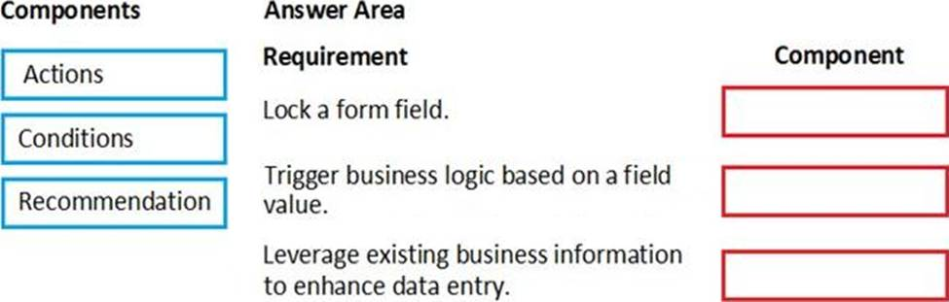
81. The sales manager receives a list of leads from a partner company monthly. The field names that are provided do not match the fields in Dynamics 365. A data map does not exist.
You need to import the leads without changing the data from the partner company.
What should you do?
- Create a data map in Data Management.
- Add a template for Import Data.
- Use Import Field Translations.
- Create a data map on the first import by using the Import Data wizard.
82. HOTSPOT
You are a Dynamics 365 Customer Engagement administrator. You create a new solution in Dynamics 365.
You need to help end users understand which actions to take next and ensure that user interaction occurs in manageable steps.
Which actions should you perform? To answer, select the appropriate options in the answer area. NOTE: Each correct selection is worth one point.
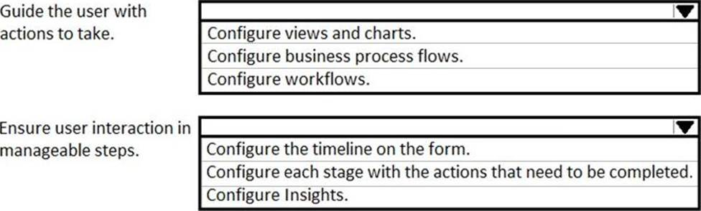
83. You create a parent entity and a child entity. The parent entity has a 1:N relationship with the child entity.
You need to ensure that when the owner changes on the parent record that all child records are assigned to the new owner.
You need to configure the relationship behavior type.
What should you use?
- Parental
- Referential, Restrict Delete
- Referential
- Restrict
84. You are a Dynamics 365 administrator for a veterinarian clinic.
On the client appointment form, there is a dropdown field for clients to select their type of pet If a client selects the option Other, the veterinarian wants a text field to appear so that additional details can be added.
You need to create a dynamically visible field.
What should you configure?
- filed visibility on the form
- business process flow
- workflow
- business rule
85. HOTSPOT
The owner of a company needs to know who signs into the system.
You need to ensure that the owner can view the user audit logs.
Where does each action need to be performed? To answer, select the appropriate options in the answer area. NOTE Each correct selection is worth one point.
